**Machine Learning**

***Course 2 –* Machine Learning: Regression**

<https://networkingfunda.com/machine-learning-regression-coursera-quiz-answers/>

**Week 1**

*Simple Linear Regression*

[https://nbviewer.org/github/tuanavu/coursera-university-of-washington/blob/master/machine_learning/2_regression/lecture/week1/quiz%20-%20Simple%20Linear%20Regression.ipynb](https://nbviewer.org/github/tuanavu/coursera-university-of-washington/blob/master/machine_learning/2_regression/lecture/week1/quiz%2520-%2520Simple%2520Linear%2520Regression.ipynb)

*Fitting a simple linear regression model on housing data*

[https://nbviewer.org/github/tuanavu/coursera-university-of-washington/blob/master/machine_learning/2_regression/assignment/week1/quiz%20-%20assignment1.ipynb](https://nbviewer.org/github/tuanavu/coursera-university-of-washington/blob/master/machine_learning/2_regression/assignment/week1/quiz%2520-%2520assignment1.ipynb)

**Week 2**

*Multiple Regression*

[https://nbviewer.org/github/tuanavu/coursera-university-of-washington/blob/master/machine_learning/2_regression/lecture/week2/quiz%20-%20Multiple%20Regression.ipynb](https://nbviewer.org/github/tuanavu/coursera-university-of-washington/blob/master/machine_learning/2_regression/lecture/week2/quiz%2520-%2520Multiple%2520Regression.ipynb)

*Exploring different multiple regression models for house price prediction*

[https://nbviewer.org/github/tuanavu/coursera-university-of-washington/blob/master/machine_learning/2_regression/assignment/week2/quiz%20-%20week2-assignment1.ipynb](https://nbviewer.org/github/tuanavu/coursera-university-of-washington/blob/master/machine_learning/2_regression/assignment/week2/quiz%2520-%2520week2-assignment1.ipynb)

*Implementing gradient descent for multiple regression*

[https://nbviewer.org/github/tuanavu/coursera-university-of-washington/blob/master/machine_learning/2_regression/assignment/week2/quiz%20-%20week2-assignment2.ipynb](https://nbviewer.org/github/tuanavu/coursera-university-of-washington/blob/master/machine_learning/2_regression/assignment/week2/quiz%2520-%2520week2-assignment2.ipynb)

**Week 3**

*Assessing Performance*

[https://nbviewer.org/github/tuanavu/coursera-university-of-washington/blob/master/machine_learning/2_regression/lecture/week3/quiz%20-%20Assessing%20Performance.ipynb](https://nbviewer.org/github/tuanavu/coursera-university-of-washington/blob/master/machine_learning/2_regression/lecture/week3/quiz%2520-%2520Assessing%2520Performance.ipynb)

*Exploring the bias-variance tradeoff*

[https://nbviewer.org/github/tuanavu/coursera-university-of-washington/blob/master/machine_learning/2_regression/assignment/week3/quiz%20-%20week3-assignment.ipynb](https://nbviewer.org/github/tuanavu/coursera-university-of-washington/blob/master/machine_learning/2_regression/assignment/week3/quiz%2520-%2520week3-assignment.ipynb)

**Week 4**

*Ridge Regression*

[https://nbviewer.org/github/tuanavu/coursera-university-of-washington/blob/master/machine_learning/2_regression/lecture/week4/quiz%20-%20Ridge%20Regression.ipynb](https://nbviewer.org/github/tuanavu/coursera-university-of-washington/blob/master/machine_learning/2_regression/lecture/week4/quiz%2520-%2520Ridge%2520Regression.ipynb)

*Observing effects of L2 penalty in polynomial regression*

[https://nbviewer.org/github/tuanavu/coursera-university-of-washington/blob/master/machine_learning/2_regression/assignment/week4/quiz%20-%20week4-assignment1.ipynb](https://nbviewer.org/github/tuanavu/coursera-university-of-washington/blob/master/machine_learning/2_regression/assignment/week4/quiz%2520-%2520week4-assignment1.ipynb)

*Implementing ridge regression via gradient descent*

[https://nbviewer.org/github/tuanavu/coursera-university-of-washington/blob/master/machine_learning/2_regression/assignment/week4/quiz%20-%20week4-assignment2.ipynb](https://nbviewer.org/github/tuanavu/coursera-university-of-washington/blob/master/machine_learning/2_regression/assignment/week4/quiz%2520-%2520week4-assignment2.ipynb)

**Week 5**

*Feature Selection and Lasso*

[https://nbviewer.org/github/tuanavu/coursera-university-of-washington/blob/master/machine_learning/2_regression/lecture/week5/quiz%20-%20Feature%20Selection%20and%20Lasso.ipynb](https://nbviewer.org/github/tuanavu/coursera-university-of-washington/blob/master/machine_learning/2_regression/lecture/week5/quiz%2520-%2520Feature%2520Selection%2520and%2520Lasso.ipynb)

*Using LASSO to select features*

[https://nbviewer.org/github/tuanavu/coursera-university-of-washington/blob/master/machine_learning/2_regression/assignment/week5/quiz%20-%20week5-assignment1.ipynb](https://nbviewer.org/github/tuanavu/coursera-university-of-washington/blob/master/machine_learning/2_regression/assignment/week5/quiz%2520-%2520week5-assignment1.ipynb)

*Implementing LASSO using coordinate descent*

[https://nbviewer.org/github/tuanavu/coursera-university-of-washington/blob/master/machine_learning/2_regression/assignment/week5/quiz%20-%20week5-assignment2.ipynb](https://nbviewer.org/github/tuanavu/coursera-university-of-washington/blob/master/machine_learning/2_regression/assignment/week5/quiz%2520-%2520week5-assignment2.ipynb)

**Week 6**

*Nearest Neighbors & Kernel Regression*

[https://nbviewer.org/github/tuanavu/coursera-university-of-washington/blob/master/machine_learning/2_regression/lecture/week6/quiz%20-%20Nearest%20Neighbors%20%26%20Kernel%20Regression.ipynb](https://nbviewer.org/github/tuanavu/coursera-university-of-washington/blob/master/machine_learning/2_regression/lecture/week6/quiz%2520-%2520Nearest%2520Neighbors%2520&%2520Kernel%2520Regression.ipynb)

*Predicting house prices using k-nearest neighbors regression*

<https://nbviewer.org/github/tuanavu/coursera-university-of-washington/blob/master/machine_learning/2_regression/assignment/week6/quiz-week6-assignment.ipynb>

***Course 3 –* Machine Learning: Classification**

<https://networkingfunda.com/machine-learning-classification-coursera-quiz-answers/>

**Week 1**

*Linear Classifiers & Logistic Regression*

<https://networkingfunda.com/machine-learning-classification-coursera-quiz-answers/>

*Predicting sentiment from product reviews*

<https://nbviewer.org/github/tuanavu/coursera-university-of-washington/blob/master/machine_learning/3_classification/assigment/week1/quiz-week1-assignment.ipynb>

*Learning Linear Classifiers*

https://networkingfunda.com/machine-learning-classification-coursera-quiz-answers/

**Week 2**

*Overfitting & Regularization in Logistic Regression*

[https://nbviewer.org/github/tuanavu/coursera-university-of-washington/blob/master/machine_learning/3_classification/lecture/week2/quiz-Overfitting%20%26%20Regularization%20in%20Logistic%20Regression.ipynb](https://nbviewer.org/github/tuanavu/coursera-university-of-washington/blob/master/machine_learning/3_classification/lecture/week2/quiz-Overfitting%2520&%2520Regularization%2520in%2520Logistic%2520Regression.ipynb)

*Logistic Regression with L2 regularization*

<https://nbviewer.org/github/tuanavu/coursera-university-of-washington/blob/master/machine_learning/3_classification/assigment/week2/quiz-week2-assignment2.ipynb>

**Week 3**

*Decision Trees*

[https://nbviewer.org/github/tuanavu/coursera-university-of-washington/blob/master/machine_learning/3_classification/lecture/week3/quiz-Decision%20Trees.ipynb](https://nbviewer.org/github/tuanavu/coursera-university-of-washington/blob/master/machine_learning/3_classification/lecture/week3/quiz-Decision%2520Trees.ipynb)

*Identifying safe loans with decision trees*

<https://nbviewer.org/github/tuanavu/coursera-university-of-washington/blob/master/machine_learning/3_classification/assigment/week3/quiz-week3-assignment1.ipynb>

*Implementing binary decision trees*

<https://nbviewer.org/github/tuanavu/coursera-university-of-washington/blob/master/machine_learning/3_classification/assigment/week3/quiz-week3-assignment2.ipynb>

**Week 4**

*Preventing Overfitting in Decision Trees*

[https://nbviewer.org/github/tuanavu/coursera-university-of-washington/blob/master/machine_learning/3_classification/lecture/week4/quiz-Preventing%20Overfitting%20in%20Decision%20Trees.ipynb](https://nbviewer.org/github/tuanavu/coursera-university-of-washington/blob/master/machine_learning/3_classification/lecture/week4/quiz-Preventing%2520Overfitting%2520in%2520Decision%2520Trees.ipynb)

*Decision Trees in Practice*

<https://nbviewer.org/github/tuanavu/coursera-university-of-washington/blob/master/machine_learning/3_classification/assigment/week4/quiz-week4-assignment1.ipynb>

*Handling Missing Data*

<https://networkingfunda.com/machine-learning-classification-coursera-quiz-answers/>

**Week 5**

*Exploring Ensemble Methods*

<https://nbviewer.org/github/tuanavu/coursera-university-of-washington/blob/master/machine_learning/3_classification/assigment/week5/quiz-week5-assignment1.ipynb>

*Boosting*

<https://nbviewer.org/github/tuanavu/coursera-university-of-washington/blob/master/machine_learning/3_classification/lecture/week5/quiz-Boosting.ipynb>

*Boosting a decision stump*

<https://nbviewer.org/github/tuanavu/coursera-university-of-washington/blob/master/machine_learning/3_classification/assigment/week5/quiz-week5-assignment2.ipynb>

**Week 6**

*Precision-Recall*

<https://nbviewer.org/github/tuanavu/coursera-university-of-washington/blob/master/machine_learning/3_classification/lecture/week6/quiz-Precision-Recall.ipynb>

*Exploring precision and recall*

<https://nbviewer.org/github/tuanavu/coursera-university-of-washington/blob/master/machine_learning/3_classification/assigment/week6/quiz-week6-assignment.ipynb>

**Week 7**

*Scaling to Huge Datasets & Online Learning*

[https://nbviewer.org/github/tuanavu/coursera-university-of-washington/blob/master/machine_learning/3_classification/lecture/week7/quiz-Scaling%20to%20Huge%20Datasets%20%26%20Online%20Learning.ipynb](https://nbviewer.org/github/tuanavu/coursera-university-of-washington/blob/master/machine_learning/3_classification/lecture/week7/quiz-Scaling%2520to%2520Huge%2520Datasets%2520&%2520Online%2520Learning.ipynb)

*Training Logistic Regression via Stochastic Gradient Ascent*

<https://nbviewer.org/github/tuanavu/coursera-university-of-washington/blob/master/machine_learning/3_classification/assigment/week7/quiz-week7-assignment.ipynb>

***Course 4 –* Machine Learning: Clustering & Retrieval**

**Week 2**

*Representations and metrics*

[https://nbviewer.org/github/tuanavu/coursera-university-of-washington/blob/master/machine_learning/4_clustering_and_retrieval/lecture/week2/quiz-Representations%20and%20metrics.ipynb](https://nbviewer.org/github/tuanavu/coursera-university-of-washington/blob/master/machine_learning/4_clustering_and_retrieval/lecture/week2/quiz-Representations%2520and%2520metrics.ipynb)

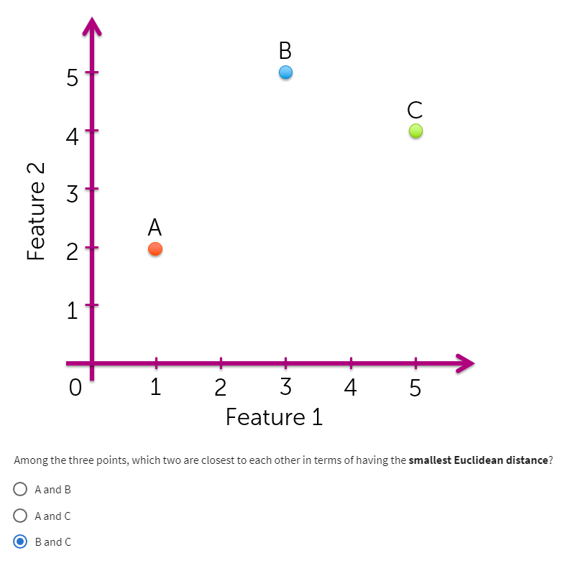

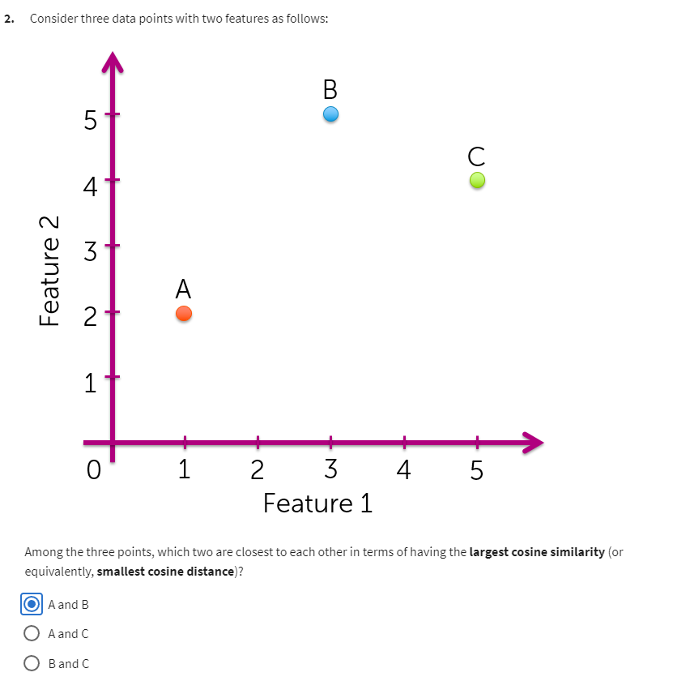

*Choosing features and metrics for nearest neighbor search*

<https://nbviewer.org/github/tuanavu/coursera-university-of-washington/blob/master/machine_learning/4_clustering_and_retrieval/assigment/week2/quiz-week2-assignment1.ipynb>

*KD-trees*

<https://nbviewer.org/github/tuanavu/coursera-university-of-washington/blob/master/machine_learning/4_clustering_and_retrieval/lecture/week2/quiz-KD-trees.ipynb>

*Locality Sensitive Hashing*

[https://nbviewer.org/github/tuanavu/coursera-university-of-washington/blob/master/machine_learning/4_clustering_and_retrieval/lecture/week2/quiz-Locality%20Sensitive%20Hashing.ipynb](https://nbviewer.org/github/tuanavu/coursera-university-of-washington/blob/master/machine_learning/4_clustering_and_retrieval/lecture/week2/quiz-Locality%2520Sensitive%2520Hashing.ipynb)

*Implementing Locality Sensitive Hashing from scratch*

<https://nbviewer.org/github/tuanavu/coursera-university-of-washington/blob/master/machine_learning/4_clustering_and_retrieval/assigment/week2/quiz-week2-assignment2.ipynb>

**Week 3**

*k-means*

<https://nbviewer.org/github/tuanavu/coursera-university-of-washington/blob/master/machine_learning/4_clustering_and_retrieval/lecture/week3/quiz-k-means.ipynb>

*Clustering text data with K-means*

**<https://nbviewer.org/github/tuanavu/coursera-university-of-washington/blob/master/machine_learning/4_clustering_and_retrieval/assigment/week3/quiz-week3-assignment1.ipynb>**

**[LINK](https://www.youtube.com/watch?v=AwVvX4Xu_FE)  
Answer in comments**

*MapReduce for k-means*

[https://nbviewer.org/github/tuanavu/coursera-university-of-washington/blob/master/machine_learning/4_clustering_and_retrieval/lecture/week3/quiz-MapReduce%20for%20k-means.ipynb](https://nbviewer.org/github/tuanavu/coursera-university-of-washington/blob/master/machine_learning/4_clustering_and_retrieval/lecture/week3/quiz-MapReduce%2520for%2520k-means.ipynb)

**Week 4**

*EM for Gaussian mixtures*

[https://nbviewer.org/github/tuanavu/coursera-university-of-washington/blob/master/machine_learning/4_clustering_and_retrieval/lecture/week4/quiz-EM%20for%20Gaussian%20mixtures.ipynb](https://nbviewer.org/github/tuanavu/coursera-university-of-washington/blob/master/machine_learning/4_clustering_and_retrieval/lecture/week4/quiz-EM%2520for%2520Gaussian%2520mixtures.ipynb)

[Link](https://www.youtube.com/watch?v=zWRp-0JPoLs) - YouTube with all answers

*Implementing EM for Gaussian mixtures*

<https://nbviewer.org/github/tuanavu/coursera-university-of-washington/blob/master/machine_learning/4_clustering_and_retrieval/assigment/week4/quiz-week4-assignment1.ipynb>

Question 2

4.9

Question 3

0.6

*Clustering text data with Gaussian mixtures*

<https://nbviewer.org/github/tuanavu/coursera-university-of-washington/blob/master/machine_learning/4_clustering_and_retrieval/assigment/week4/quiz-week4-assignment2.ipynb>

1. except the last one

**Week 5**

*Latent Dirichlet Allocation*

[https://nbviewer.org/github/tuanavu/coursera-university-of-washington/blob/master/machine_learning/4_clustering_and_retrieval/lecture/week5/quiz-Latent%20Dirichlet%20Allocation.ipynb](https://nbviewer.org/github/tuanavu/coursera-university-of-washington/blob/master/machine_learning/4_clustering_and_retrieval/lecture/week5/quiz-Latent%2520Dirichlet%2520Allocation.ipynb)

*Learning LDA model via Gibbs sampling*

[https://nbviewer.org/github/tuanavu/coursera-university-of-washington/blob/master/machine_learning/4_clustering_and_retrieval/lecture/week5/quiz-Learning%20LDA%20model%20via%20Gibbs%20sampling.ipynb](https://nbviewer.org/github/tuanavu/coursera-university-of-washington/blob/master/machine_learning/4_clustering_and_retrieval/lecture/week5/quiz-Learning%2520LDA%2520model%2520via%2520Gibbs%2520sampling.ipynb)

*Modeling text topics with Latent Dirichlet Allocation*

<https://nbviewer.org/github/tuanavu/coursera-university-of-washington/blob/master/machine_learning/4_clustering_and_retrieval/assigment/week5/quiz-week5-assignment.ipynb>

[Link](https://www.youtube.com/watch?v=D1ueThAR-ro) YouTube

**Week 6**

*Modeling text topics with Latent Dirichlet Allocation*

Question 1

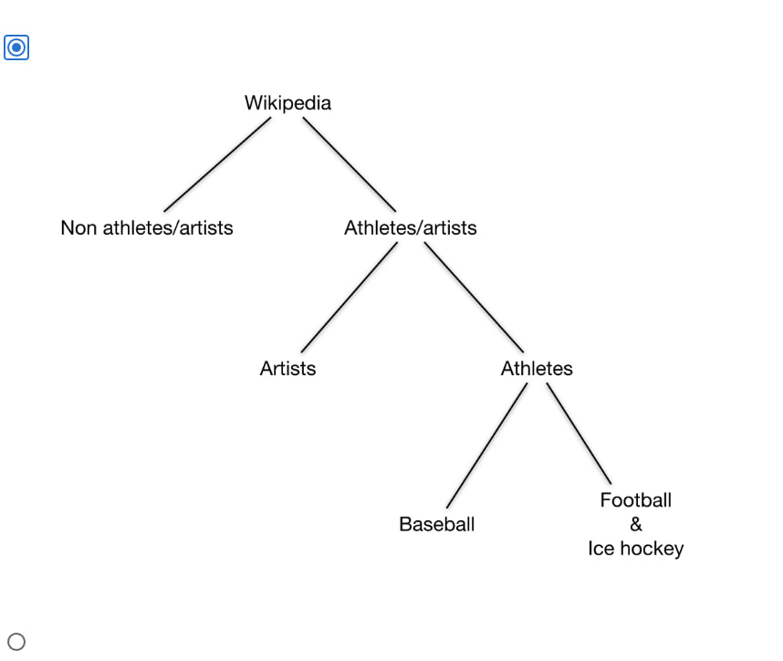

Question 2

